Dynamics of Disruption: How Security and Constitutional Events Shape Multidimensional Political Extremism
Amir Freund
Contact: Amir Freund, amir61@gmail.com

Abstract
This study investigates how destabilizing events correlate with shifts in political extremism across different political orientations. The research uses longitudinal data from six survey waves conducted in Israel between 2021 and 2024. Current research on extremism often relies on fragmented frameworks and one-dimensional methodologies. To address these gaps, this study develops a multidimensional theory of political extremism that integrates cognitive, behavioral, and social dimensions. This framework uses the Political Extremism Gauge, a context-independent instrument designed for cross-population comparative analysis. The findings challenge the assumption of uniform radicalization. Identical destabilizing events simultaneously mobilize and demobilize different political groups. The analysis reveals that the three dimensions of political extremism respond independently rather than uniformly during periods of instability. A critical insight of this research is that political events influence extremism levels primarily through recruitment and demobilization mechanisms. Events bring new individuals into the extreme tail of the distribution or cause others to leave it. This process differs from the incremental radicalization of individuals who are already extremists. These results suggest that extremism is a reactive phenomenon moderated by political orientation and the specific nature of the perceived threat. This study provides a universal methodology for monitoring democratic resilience and analyzing societal responses to disruption.

Keywords: Political extremism; Destabilizing events; Political orientation; Multidimensional measurement; Democratic resilience

Introduction
Political extremism poses a critical threat to democratic countries (Bennett & Livingston, 2025; Ferrer & Palmisano, 2025). The study of political extremism faces three critical barriers that limit our understanding of this phenomenon. First, political extremism remains undefined in any universally accepted way, creating conceptual ambiguity (Bötticher, 2017; Eatwell & Goodwin, 2010; Sotlar, 2004; Svetlichny & Khorev, 2022). The term’ extremism’, rather than ‘political extremism’, is used even in an apparent political context (Onursal & Kirkpatrick, 2021; Scruton, 2007; UK Parliament, 2024). Absolute and relative approaches coexist within the current academic discourse. Relative definitions position extremists at the edges of the political spectrum, outside the mainstream, taking political ideas to their logical extremes (Coleman & Bartoli, 2015; Mandel, 2010; Scruton, 2007; Wintrobe, 2006). Absolute definitions associate a specific ideological content with political extremism, such as opposing a democratic constitutional state (Jungkunz, 2022; Midlarsky, 2011), monism (Eatwell & Goodwin, 2010), and a disregard for the lives, liberties, and human rights of others (Scruton, 2007). The fragmentation of the term into various subtypes may lead to differing interpretations and conclusions, creating ambiguity (Bjelopera, 2017) and challenging our capability to frame the phenomenon. Further contributing to the lack of clarity is the use of other terms, such as ‘radicalism’ and ‘terrorism,’ which overlap in definition (Allchorn & Orofino, 2023). Although much of the current literature emphasizes right-wing and Islamist extremism, the development of a truly universal definition necessitates an inclusive approach that captures additional extremist forms such as left-wing, environmental, and other ideologically motivated variants.
Second, the field tends to fragment extremism into discrete dimensions rather than studying it as an integrated whole. This fragmentation impedes cumulative theory-building and produces incompatible empirical findings. Relying on a single feature or dimension when assessing political extremism can lead to overlooking various forms of it (Schmid, 2014) or to a biased understanding of the phenomenon. The ideological position is evident in almost all definitions of political extremism; however, its conceptualization and measurement vary significantly. Many scholars limit the definition to a left-right political position (van Prooijen & Krouwel, 2019, 2022) using an ideological self-positioning scale to identify political extremism (Rigoli, 2023; Uba & Bosi, 2022; van Prooijen et al., 2015; van Prooijen & Kuijper, 2020). Other scholars use additional dimensions, including authoritarianism (Mudde, 1995), beliefs in superiority and intolerance towards opposing groups (Doosje et al., 2016; Ozer & Bertelsen, 2018), endorsement of violence (Schmid, 2013; Wintrobe, 2006), anti-democracy (Jungkunz, 2022; Mudde, 1995), actions toward replacing the dominant political system (Jackson, 2019), and the belief in a monopoly on truth (Dono et al., 2018).
Third, cross-national comparisons prove challenging because extremism thresholds vary significantly across different political contexts. Cultural and political contexts shape definitions of extremism, leading to identical positions receiving different classifications across nations (Zuell & Scholz, 2019). Citizens of countries suffering from long-standing, deep-seated conflicts may perceive political violence as less extreme than that in countries with established peace and political stability (Canetti et al., 2009). Female extremist politicians in parliament might soften the perception of political extremism (Ben-Shitrit et al., 2022). People associate different political meanings with the terms ‘left’ and ‘right’ (Bauer et al., 2017; Jungkunz, 2022). Dolezal (2010) demonstrates that European Green voters can be difficult to categorize on a left-right economic or social scale. However, their environmental positions might be considered “extreme” in mainstream politics. This context-dependent challenge is further exacerbated by the lack of standardized, consistent survey measures or scales to assess political extremism over time and across population groups (Jungkunz, 2022).

New Conceptualization
In response to these challenges, this paper advances a new, multidimensional conceptualization of political extremism (see Figure 1) grounded in three core dimensions: Cognitive (Ideological positions), Behavioral (Support of violence), and Social (Intolerance toward outgroups).
Figure 1: Conceptualization of Political Extremism
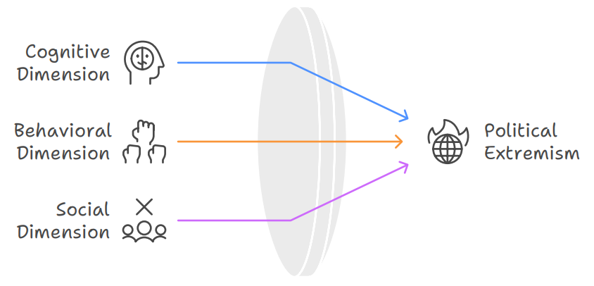
The Cognitive dimension examines how firmly individuals hold their sociopolitical beliefs and the degree of rigidity characterizing their ideological commitments (Jost et al., 2009). This perspective moves away from categorizing extremism along a left-right spectrum (Schmid, 2013; Sedgwick, 2010) and instead emphasizes the inflexibility and intensity with which people maintain their views (Zmigrod et al., 2019). The Behavioral dimension analyzes the extent to which individuals endorse and justify unconventional political tactics (Backer & Tausch, 2017; Shuman et al., 2016; Schumpe et al., 2020), spanning from unlawful demonstrations to armed confrontation. This aspect concerns the acceptance of forceful means to achieve political goals (Steinhoff & Zwerman, 2008), including attacks on governmental structures intended to redistribute authority and resources (Weber, 1978), as well as violence between social groups (Tilly, 2003). The continuum extends from lawful, peaceful activities to acts of civil disobedience, and then to violent tactics and terrorist operations (Shuman et al., 2021). The Social dimension addresses how individuals exclude others from political participation and personal association, irrespective of those individuals’ group memberships. This aspect embodies the denial of pluralistic values and the erosion of equal rights and freedoms for all members of society (Backes, 2010; Scruton, 2007). It includes unwillingness to extend full civic participation to others (Gibson & Bingham, 1982; Sullivan et al., 1979) alongside interpersonal distancing driven by political or demographic differences (Ben Shitrit et al., 2017; van Prooijen & Krouwel, 2019). This dimension investigates how people delegitimize rival perspectives and communities (Dono et al., 2018; Schmid, 2014; Waddell et al., 2024), independent of the particular ideologies or identities involved.
The theoretical contribution consists of synthesizing the most referenced dimensions within the academic discourse into a comprehensive, multidimensional conceptualization of political extremism, thereby capturing the complex interplay between cognitive, behavioral, and social manifestations of extreme political attitudes and behaviors. Although the research selects specific dimensions, the conceptualization is not constrained by particular ideological orientations, violence categories, or target outgroups. This design enables a comprehensive assessment of different extremist forms within a single methodological framework, while also allowing for direct comparison between them.

Destabilizing Events and Political Extremism
Destabilizing events directly threaten the stability, legitimacy, or continuity of established political systems. While existing research has typically focused on specific types of events in isolation, usually linking individual events to a single dimension of political extremism (Canetti et al., 2013, 2018; Hirsch-Hoefler et al., 2014; Ozer et al., 2025), there has been a limited systematic examination of how different categories of destabilizing events affect multiple dimensions of extremism in distinct ways. Moreover, various political orientations may respond differently to the same events, where identical stimuli may increase extremism within certain ideological groups while reducing it within others, making separate analysis by political orientation necessary to capture these differential effects. The present study addresses both research gaps by systematically examining how various types of destabilizing events affect multiple dimensions of political extremism across different political orientations.
Various destabilizing events can contribute to the emergence of political extremism. National crises, including wars and economic depressions, consistently correlate with increased extremism domestically, both on the right and the left (Kofman & Garfin, 2020; Rasler, 1986; Stohl, 1975; Vlachos, 2016). Immigration crises and large refugee influxes boost support for radical-right parties (Dinas et al., 2019) while state repression and the rise of the far-right contribute to left-wing extremism (Krüsselmann & Weggemans, 2023). Events perceived as group-based injustices or in-group disadvantages similarly catalyze political violence (Pauwels & Heylen, 2020; Pretus et al., 2023). The influence of electoral events on extremism appears more complex; although most studies indicate temporary spikes in partisan hostility during elections that subsequently subside (Jungkunz et al., 2024; Michelitch & Utych, 2018). Evidence from the 2022 U.S. elections suggests that these elections have had more persistent effects on partisan animosity and support for political violence (Fasching et al., 2024). Natural disasters and health crises create particularly fertile ground for extremism, with evidence showing that such events enable extremist groups to exploit public anxiety through disinformation and anti-government narratives (Khalil, 2021), as notably demonstrated by the effect of the COVID-19 pandemic on extremist online activity (Davies et al., 2023; Marone, 2022).
Political orientation plays a crucial moderating role in shaping how citizens’ levels of extremism change in response to destabilizing events across Western democracies. Individuals with right-wing political orientations demonstrate stronger associations with extremist attitudes compared to their left-wing counterparts, particularly regarding support for political violence and outgroup intolerance(Van Hiel et al., 2020). Studies comparing political violence across ideologies reveal that individuals affiliated with left-wing causes are consistently less likely to engage in violent behavior. At the same time, right-wing extremists show higher propensities for deadly attacks (Jasko et al., 2022). Evidence from Western societies indicates that political violence and hate crimes, two key manifestations of extremism, are overwhelmingly more likely to originate from individuals with right-wing political orientations than those with left-wing orientations (Jost, 2024). Right-wing political orientation correlates strongly with xenophobia, racism, anti-Semitism, and exclusion of ethnic and racial minorities (Jungkunz et al., 2024). However, left-wing political orientation can also lead to extremist manifestations, including intolerance toward perceived enemies such as capitalists, fascists, and supporters of traditional authority structures, with some left-wing groups promoting systematic persecution of outgroups based on class or political ideology (Guhl, 2025). Cross-national studies indicate that right-wing authoritarianism specifically predicts prejudice against groups perceived as socially threatening. At the same time, both political orientations can foster anti-pluralist attitudes and rejection of democratic norms when combined with extremist ideological positions (Costello et al., 2022).
This study represents the first empirical examination of how various destabilizing events differentially correlate with levels of political extremism among citizens with different political orientations across multiple dimensions of political extremism. This research tests the hypotheses that (H1) various dimensions of political extremism do not respond uniformly to socio-political events and (H2) the effect of different destabilizing events will be moderated by political orientation. The novel conceptual and methodological framework enables bias-free comparative analysis across multiple dimensions, distinguishing between different political orientations, various destabilizing events, and manifestations of extremism.

The Current Research
The research applies the new conceptualization of political extremism to examine how different destabilizing events, including security threats, political transitions, and constitutional crises, correlate with specific dimensions of extremism among Israeli Jewish citizens across distinct political orientations (left-wing, center-wing, right-wing). The three primary hypotheses are: (H1) various dimensions of political extremism respond heterogeneously to socio-political events, (H2) political orientation moderates these responses, and (H3) focusing on the more extreme population enables a more nuanced understanding of political extremism and radicalization processes.
The study introduces a novel Political Extremism Gauge that simultaneously measures all three dimensions, transforming them into indices of political extremism.
Implementing the research in Israel provides distinct methodological advantages: the population experiences genuine, high-intensity security and political threats across multiple domains, avoiding the validity limitations of laboratory simulations; Israel’s compact geography enables researchers to study populations facing similar objective threats while exhibiting potentially different subjective characteristics; and Israel’s democratic tradition makes the study potentially applicable to other democracies.
The political orientation measure incorporates center-wing orientations alongside traditional left-wing and right-wing perspectives. Following the end of the Second Intifada (2000-2005), centrist parties established themselves as significant political entities in Israel (Agmon, 2025; Talshir, 2019). Approximately 25-33% of Israeli voters regularly support centrist parties, constituting an expanding bloc of predominantly educated middle-class citizens who remain committed to centrist alternatives rather than shifting between left and right poles (Talshir, 2019).

Materials and Methods
The empirical analysis utilizes a comprehensive six-wave study conducted among Jewish Israelis between 2021 and 2024. Waves one (12/6/2021-01/13/2022, N=1608), two (05/23/2022-06/24/2022, N=1607), three (10/24/2022-10/31/2022, N=886), five (06/20/2023-06/26/2023, N=1524), and six (04/04/2024-04/30/2024, N=1114), employed randomly selected, nationally representative samples; wave four (01/12/2023-01/25/2023, N=671) functioned as a panel subset of wave three..
Each wave pair coincided with a major destabilizing event, creating a quasi-experimental setting to observe shifts in political extremism. The events included: (i) Inland terror attacks in key Israeli cities, (ii) The dissolution of the Lapid-Bennett “Unity” government, leading to Israel’s fifth election in nearly four years. The Unity government ended 12 years of right-wing governance under Netanyahu, and its dissolution after less than two years signalled the failure to establish an alternative to Netanyahu. (iii) The introduction of judicial Reform by the new Netanyahu government. (iv) Netanyahu’s dismissal of Defense Minister Gallant over his opposition to judicial reforms sparked immediate demonstrations across Israel. Protesters disrupted major highways and gathered at key political sites, forcing Netanyahu to pause the legislation to prevent “civil war.” Continued public pressure ultimately compelled the Prime Minister to reinstate Gallant two weeks later. (v) The October 7 War is referred to as the deadliest day for jews since the Holocaust, with a timing that is potentially connected to the strong divisions within the Israeli population due to the Judicial Reform.
The calculation of political extremism dimensions combines multiple related survey items into a single variable using Confirmatory Factor Analysis (CFA). Each dimension uses a 1-to-7 scale, with 1 representing a low level of extremism and seven a high level of extremism. Respondents’ self-reported political affiliations, rated on a 1-to-7 scale (where 1 represents right-wing and 7 represents left-wing), are converted into three political orientation categories: right (1-3), center (4), and left (5-7). Control variables include Gender (male, female) and Age Group (18-30, 31-45, 46-60, 60+).

Political Extremism Gauge
The Political Extremism Gauge converts the three dimensions into indices to assess the political extremism of different groups. The gauge utilizes two categories of indices: Absolute and Relative. Absolute indices derive directly from the three dimensions and represent the central tendency of a population. Relative indices represent the degree of divergence from that central tendency. These relative indices provide a valid basis for comparative research because they account for population-specific factors such as cultural response styles and national political contexts.

Figure 2: Operationalization of Political Extremism
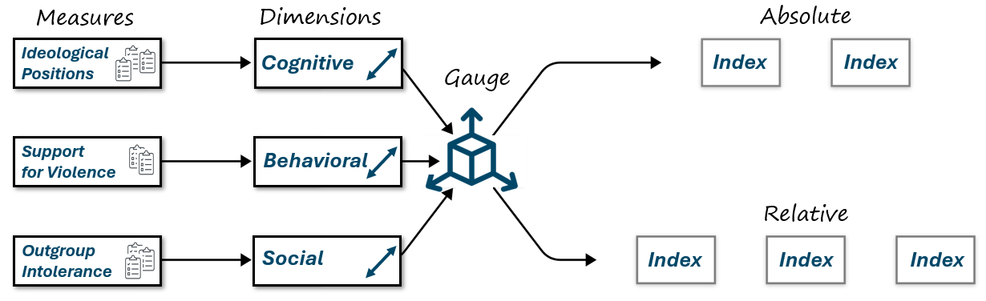
The gauge uses a universal set of dimensions to ensure the instrument remains context-independent. However, the identification of the extremist segment is relative to the specific population norm. This approach shifts the analytical focus from raw values to the degree of deviation from a societal center. This standardization neutralizes local idiosyncrasies. It allows researchers to compare how distinct populations diverge from their respective norms without the confounding influence of context-dependent baselines.
Absolute indices include the Normative Point (NP), which represents the population median in each dimension, and the Extremism Point (EP), which serves as a threshold to identify the more extreme population. The Extremism Point (EP) serves as the threshold to identify the more extreme segment of the population. The calculation of the EP must delineate the distributional tail of the extremism spectrum. The EP is operationalized by adding 1.5 times the Median Absolute Deviation (MAD) to the established Normative Point (NP): EP = NP + 1.5 * MAD. Selecting K=1.5 serves two objectives. First, it excludes moderate individuals from the extremist tail. Second, it maintains a sufficient sample size and a sufficient resolution (number of unique values) to enable robust statistical analysis. The Supplementary Information (SI) appendix provides a detailed comparison of different tail identification methods. The SI also contains a sensitivity analysis that demonstrates why K=1.5 offers the optimal balance between resolution and exclusionary precision for this dataset.

Relative indices include Extremism Levels (EL) and Extremism Intensity (EIN). EL represents the percentage of the group above the EP in each dimension. EIN represents the mean intensity of that group. The indices also include three Extremism Ranks (ER1, ER2, ER3). These ranks represent the population percentage with at least one, two, or three dimensions above the EP.
Figure 3: Gauge Indices
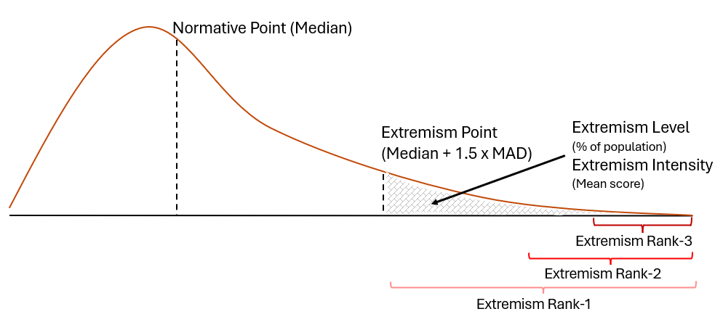
The utilization of relative indices resolves critical validity challenges inherent in cross-national or longitudinal comparative research. Comparative analysis frequently encounters obstacles arising from contextual heterogeneity, such as varying national interpretations of the left-right ideological spectrum, culturally or historically dependent thresholds for acceptable violence, and distinct definitions of relevant outgroups. Relative indices mitigate these biases by shifting the analytical focus from raw values to the degree of deviation from a population-specific norm. This standardization neutralizes local idiosyncrasies and isolates the structural phenomenon of extremism, allowing researchers to compare how distinct populations diverge from their respective societies’ centers without the confounding influence of context-dependent baselines.

Results

Does political affiliation moderate the impact of destabilizing events?
The analysis begins by examining how political affiliations (left-wing, center-wing, right-wing) moderate the association of various destabilizing events with political extremism across the dimensions of political extremism. This study uses Multivariate Analysis of Variance (MANOVA) on each consecutive pair of Political Extremism Survey waves. For the panel survey waves (3 and 4), the analysis employs a Repeated-Measures MANOVA. Separate analyses explore the entire population and its more extreme segment. The MANOVA model includes the occurrence of the destabilizing event (0 for the first wave and 1 for the second), political orientation, control variables for religiosity, education, gender, and age group, and an interaction between the destabilizing event and political orientation.
The results of the MANOVA analysis across the entire population (Table 1) indicate that the Inland Terror event had the most significant multivariate impact on the dimensions of political extremism ($V = 0.019, p < .001, \eta^2 = 0.019$). While the main effects of other events, such as the Fall of the Bennett Government or the October 7th War, did not reach statistical significance at the multivariate level for the whole population, the interaction between the Event and Political Orientation was significant across several stages. Notably, the Inland Terror event ($V = 0.013, p < .001$), the Gallant Dismissal ($V = 0.006, p < .05$), and the October 7th War ($V = 0.005, p < .05$) all showed significant interactions, suggesting that the impact of these crises on extremism is moderated by whether an individual identifies as left-wing, center-wing, or right-wing.

Table 1: MANOVA results across the entire population
Variable | Inland Terror | Bennet Gov. Fall | Judicial Reform § | Gallant Dismissal | Oct. 7th War
Destabilizing Event | 0.019***  η²=0.019 | 0.001  η²=0.001 | 0.002  η²=0.002 | 0.002  η²=0.002 | 0.001  η²=0.001
Political Orientation | 0.066**  η²=0.033 | 0.124**  η²=0.062 | 0.135**  η²=0.067 | 0.095**  η²=0.047 | 0.066**  η²=0.033
Religiosity | 0.056**  η²=0.019 | 0.053**  η²=0.018 | 0.055***  η²=0.018 | 0.046**  η²=0.015 | 0.045**  η²=0.015
Education | 0.021***  η²=0.007 | 0.018***  η²=0.006 | 0.035***  η²=0.012 | 0.022***  η²=0.007 | 0.020***  η²=0.007
Gender | 0.032**  η²=0.032 | 0.037**  η²=0.037 | 0.056**  η²=0.056 | 0.053**  η²=0.053 | 0.045**  η²=0.045
Age Group | 0.040**  η²=0.013 | 0.050**  η²=0.017 | 0.071**  η²=0.024 | 0.043**  η²=0.014 | 0.037**  η²=0.012
Event × Political Orientation | 0.013***  η²=0.006 | 0.003  η²=0.002 | 0.007†  η²=0.004 | 0.006*  η²=0.003 | 0.005*  η²=0.002
Test statistic: Pillai's Trace. η² = partial eta-squared (effect size). *** p < .001; ** p < .01; * p < .05; † p < .10. § Panel analysis (same respondents across waves). Destabilizing Event: {0/1}, Political Orientation: {left/center/right}, Religiosity: {secular, traditional, religious, national religious, ultra-orthodox}, Education: {elementary, high school, post-secondary nonacademic, academic, yeshiva, other}, Gender: {male, female}, Age Group: {18-30, 31-45, 46-60, 60+}
A summary of per-dimension ANOVA for the entire population (Table 2) reveals that the Ideology dimension is the most reactive to external shocks. Significant shifts in ideological extremism were observed following Inland Terror (F = 17.580, p < .001), the Fall of the Bennett Government (F = 5.255, p < .05), and the October 7th War (F = 4.685, p < .05). Interestingly, the Violence dimension showed a significant main effect only during the Inland Terror event (F = 5.054, p < .05). In contrast, the Intolerance dimension remained statistically stable across all events when looking at the population as a whole.
Table 2: ANOVA results for each dimension (Entire population)
Dimension | Inland Terror | Bennet Gov. Fall | Judicial Reform § | Gallant Dismissal | Oct. 7th War
Ideology | 17.580***  (-0.100) | 5.255*  (+0.233) | 0.261  (+0.001) | 0.069  (-0.026) | 4.685*  (+0.233)
Violence | 5.054*  (+0.033) | 1.445  (-0.038) | 0.345  (+0.089) | 0.571  (+0.014) | 2.103  (+0.118)
Intolerance | 0.000  (-0.045) | 0.000  (-0.005) | 0.035  (+0.019) | 0.000  (+0.047) | 0.000  (+0.001)
Values are F-statistics with significance stars. Mean shifts (Wave 2 - Wave 1) on the 1–7 scale are provided in parentheses for event effects. *** p < .001; ** p < .01; * p < .05; † p < .10.
When narrowing the analysis to the more extreme population (those extreme in at least two dimensions), the results (Table 3) change substantially, indicating much greater sensitivity to destabilizing events. During the Inland Terror event, all three dimensions showed highly significant shifts: Ideology (F = 32.186, p < .001), Violence (F = 8.849, p < .01), and Intolerance (F = 18.831, p < .001). Compared to the entire population, the mean shifts among extremists were far more pronounced. For example, the Ideology mean shift was -0.954 among extremists, compared to -0.100 among the general population. This confirms that focusing on the "extreme tail" uncovers radicalization processes—specifically in behavioral support for violence and social intolerance—that are masked when only observing population medians.
Table 3: ANOVA results for each dimension (Extremists population)
Dimension | Inland Terror | Bennet Gov. Fall | Judicial Reform § | Gallant Dismissal | Oct. 7th War
Ideology | 32.186***  (-0.954) | 3.953*  (+0.398) | 0.676  (-0.381) | 0.002  (+0.097) | 1.125  (+0.321)
Violence | 8.849**  (+0.361) | 2.740†  (-0.427) | 0.240  (+0.298) | 1.537  (+0.114) | 0.233  (+0.088)
Intolerance | 18.831***  (+0.557) | 1.656  (-0.186) | 0.383  (+0.182) | 0.193  (-0.067) | 0.115  (-0.059)
Values are F-statistics with significance stars. Mean shifts (Wave 2 - Wave 1) on the 1–7 scale are provided in parentheses for event effects. *** p < .001; ** p < .01; * p < .05; † p < .10.
The findings provide strong support for the three primary hypotheses. First, the dimensions of extremism respond heterogeneously; while Ideology is sensitive across the board, the Social (Intolerance) and Behavioral (Violence) dimensions fluctuate significantly only within the extremist subset during major security threats. Second, the significant MANOVA interactions confirm that political orientation moderates how citizens react to these crises. Finally, the stark differences between the whole population and the extremist subset validate the research framework: analyzing the extreme tail is essential for a nuanced understanding of radicalization. While the general population may show only slight ideological shifts, the extremist subset exhibits significant fluctuations across all dimensions, particularly during periods of heightened security or political instability.

Dynamics of Political Extremism
To better understand the dynamics of political extremism associated with destabilizing events, this study conducted a longitudinal analysis of multiple gauge indices (Extremism Level, Extremism Intensity, and Extremism Rank). Figure 5 shows political extremism across the six waves and for each dimension, examining the percentage of the population in the extreme tail (EL). In the Cognitive dimension, the Left exhibits the most volatile trend, with EL scores climbing sharply from 34% in the First wave to a peak of 62% in the Third wave (Judicial Reform), before settling at 50% in the Sixth wave (October 7th War). In contrast, the Right shows a steady decline in ideological extremism, starting at 22% and reaching its lowest point of 11% by the Sixth wave. The Center remains relatively stable but low, fluctuating between 13% and 19%. In the Behavioral dimension, both the Left and Center show a long-term upward trajectory in support for violence; the Left rises from 20% in the Second wave to 39% in the Sixth, while the Center follows a similar path, ending at 39%. Conversely, the Right’s behavioral extremism decreases significantly from 40% in the First wave to 28% in the Sixth. The Social dimension reveals a stark and persistent divide: the Right maintains high levels of intolerance throughout, peaking at 28% in the Second wave and ending at 23%, while the Left remains consistently low, even hitting 0.00 in the Fourth wave.
Comparing these trends across orientations highlights a "crisscross" effect between the Left and Right, depending on the dimension and event. For instance, while the Left reacted to the Judicial Reform (Third wave) with a massive surge in Cognitive extremism (62%), the Right actually saw a slight decrease in that same dimension (14%). However, in the Social dimension, the Right’s extremism levels are consistently double or triple those of the Center and Left across all waves. Behavioral extremism shows a unique convergence by the Sixth wave, where the Left (39%) and Center (39%) surpassed the Right (28%) in their support for violence against the state or out-groups, suggesting that the October 7th War and the preceding constitutional crises impacted the political center and left more aggressively in terms of behavioral radicalization.
Figure 4: Dynamics of Extremism Levels
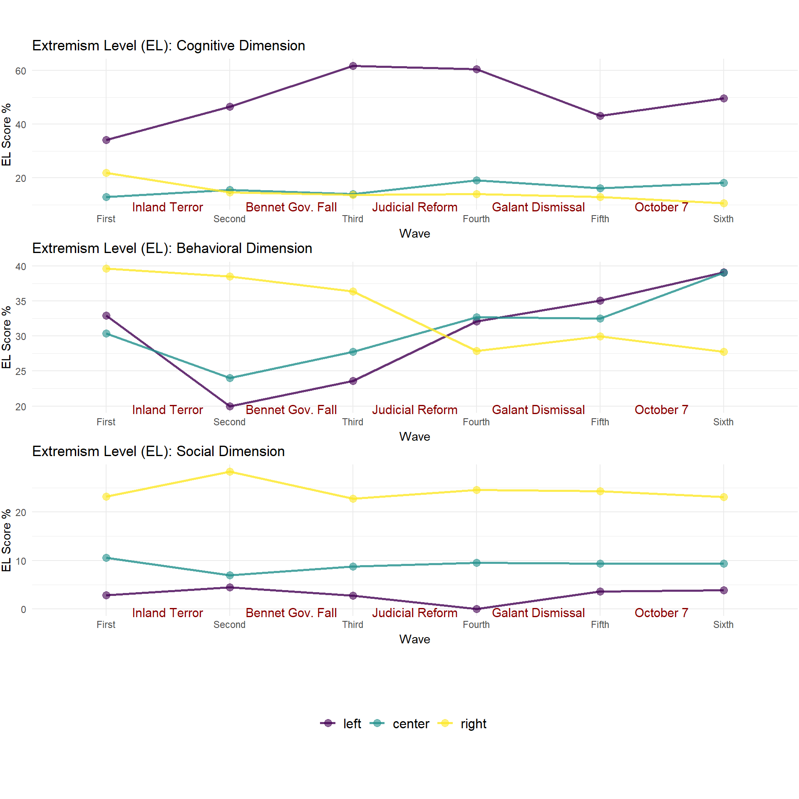
Figure 5 shows the mean extremism score of the extreme tail of the population (EIN). In the Cognitive dimension, the intensity of extremism remains high and remarkably stable across all groups, with the Left ranging from 6.81 to 6.84. At the same time, the Right shows a slight recovery from a low of 6.04 in the Second wave to 6.73 in the Sixth. The Behavioral dimension shows more movement, particularly for the Left, where intensity peaks at 2.90 in the Sixth wave (October 7th War) after a period of fluctuation. The Center and Right show more consistent intensity levels, with the Right maintaining a score of 2.72 and the Center at 2.58 by the final wave. In the Social dimension, the Right remains the most intense group throughout most of the study, peaking at 6.26 in the Third wave. Following the Bennet Gov. Fall, all three groups exhibit high and tightly clustered intensity scores around 6.1–6.25.
Figure 5: Dynamics of Extremism Intensity
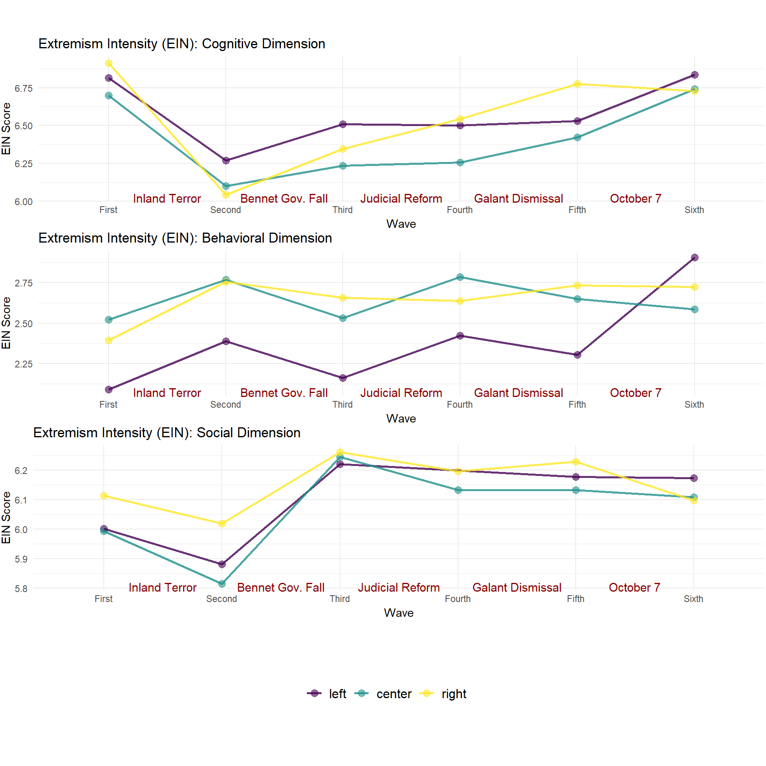
Comparing these trends reveals that while the number of extremists (EL) varies significantly by event, the intensity (EIN) of those who are extreme is relatively high and uniform across orientations. For example, in the Social dimension, although the Right has a much higher percentage of extremists than the Left, those individuals on the Left who are extreme are nearly as intense (6.17) as those on the Right (6.10). In the Behavioral dimension, a notable shift occurs in the Sixth wave; the Left’s intensity (2.90) surpasses both the Center (2.58) and the Right (2.72), suggesting that the October 7th War not only increased the number of extreme individuals on the Left but also deepened the severity of their support for violence.
The Extremism Rank 2 (ER2) data (Figure 6), which tracks the percentage of respondents extreme in at least two dimensions, reveals distinct trajectories for each political orientation. The Left shows an overall upward trend in multidimensional extremism, rising from 13% in the First wave to a peak of 19% in the Fifth wave (Gallant Dismissal), then declining to 14% in the Sixth wave. The Center follows a similar "hump" pattern, but at lower levels: starting at 7%, dipping to 3% during the Judicial Reform, then jumping significantly to 10% in the Fourth wave, and ending at 9%. In contrast, the Right exhibits a consistent and sharp decline in multi-dimensional extremism. The Right began as the most extreme group at 19% and peaked at 20% in the Second wave (Fall of the Bennett Government), but it steadily decreased thereafter, reaching its lowest point of 11% by the Sixth wave (October 7th War).
Figure 6: Dynamics of Overall Population Extremism Rank 2
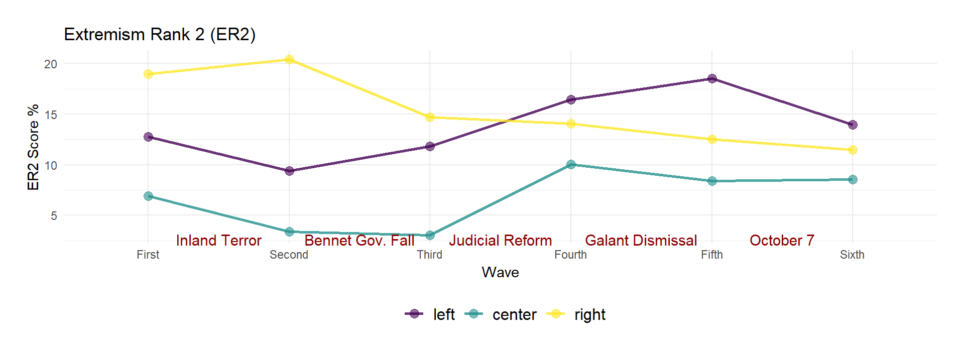
Comparing these trends highlights a significant shift in the landscape of multi-dimensional extremism over time. In the first two waves, the Right was significantly more likely to be extreme in multiple dimensions than the Left and Center. However, by the Fourth wave, the Left (16%) surpassed the Right (14%) and maintained that lead through the end of the study. The Center’s dramatic increase from the Third wave (3%) to the Fourth wave (10%) suggests that specific constitutional and political crises, such as the Gallant Dismissal, acted as powerful catalysts for multidimensional radicalization among non-right-wing citizens. By the Sixth wave, the Left (14%) and the Right (11%) have moved closer together in their ER2 scores, though they arrived at those scores from opposite directions.

Characteristics of the Extremist Population
The research examined the characteristics (political orientation, outgroup, gender, and age) of the more extremist population group, which had at least two dimensions with scores above the extremism threshold (EP). The most striking trend is the shift in the political identity of ER2 extremists. In the first three waves, the right-wing heavily dominates this group, peaking at 82.27% in the second wave. However, starting with the Judicial Reform (Wave 4), this dominance drops sharply to 58.42% and stays below 60% thereafter. Simultaneously, the left-wing presence in the ER2 group nearly doubles, rising from 10.45% to a peak of 22.89% by the fifth wave. This suggests that constitutional crises “recruit” individuals from the left and center into multidimensional extremism, making the extreme tail more politically diverse over time.
Intolerance toward Israeli Arabs within the ER2 population shows a clear reactive pattern to security vs. political threats. In the second wave (Inland Terror), over half (52.27%) of the ER2 population identified Israeli Arabs as their least-liked group. In comparison, only 33.62% of the general population shared this specific outgroup preference. This figure dropped significantly during the Judicial Reform and Gallant Dismissal (Waves 4 and 5) as political outgroups became more salient. However, it surged back to 37.88% following the October 7 war. This highlights how security threats refocus extremist hostility toward ethnic outgroups, while political crises temporarily diffuse that focus.
There is a profound gap between support for violence against the state and the outgroup. While the ER2 population shows relatively low support for attacking state institutions (peaking at 1.93), their support for violence against their outgroup is extreme, reaching 6.86 in the second wave. Even at its lowest point in the fifth wave (4.46), it remains significantly higher than any other violence metric. This indicates that multidimensional extremism in this context is primarily “horizontal” (targeting different social groups) rather than “vertical” (targeting the state regime).
The gender distribution within the ER2 group remains consistently skewed toward men when compared to the general population. While the overall population is split evenly at approximately 50%, the ER2 group is heavily male-dominated, reaching 66.04% in the third wave. Even as the political orientation of this group shifted and the total number of extremists fluctuated, the male majority remained robust, never falling below 56%.
Finally, the age of the ER2 population reveals a significant shift in the demographic profile of multidimensional extremists as destabilizing events progressed. In the initial waves, the extreme tail was younger than the general population, with a median age of 36.00 in the first wave. However, the median age increased steadily during the later periods, jumping from 37.50 during the fall of the government to 43.00 during the Judicial Reform. This demographic aging peaked after the October 7th War, where the median age of ER2 extremists reached 49.00, surpassing the general population median of 47.00. These findings suggest that while initial extremism may have been more prevalent among younger individuals, later constitutional crises and existential security threats radicalized older populations.

Robustness Analysis
The primary robustness test evaluates the gauge’s ability to identify the more extreme group and whether differences in demographic composition might confound the main results. A strong association between extremist profiles and the extremism ranking indices (ER1, ER2, and ER3) will validate the core of the political extremism gauge.
A Latent Profile Analysis (LPA) revealed five distinct profiles along the dimensions of political extremism, achieving a strong classification quality with an entropy value of 0.754. Table 4 summarizes these findings, showing the average extremism scores for each profile dimension in the Cognitive, Behavioral, and Social columns. Profile 3 emerged as the most extremist group, followed by Profile 1 as the second-most extremist, based on their dimension means. The ER1, ER2, and ER3 columns indicate what percentage of each profile’s members fall into extremist-ranked categories according to these three indices.
Table 4: Association of latent profiles with the more extremist population
Profile² |  | Profile Means |  |  | Proportions of Binary Characteristics¹
Profile² | N | Cognitive | Behavioral | Social | ER1 | ER2 | ER3
1 | 1362 | 4.046 | 1.540 | 4.447 | 88.2% | 26.1% | 3.6%
2 | 3347 | 4.058 | 1.041 | 3.477 | 31.5% | 3.8% | 0.0%
3 | 1256 | 3.310 | 3.240 | 4.399 | 100.0% | 32.1% | 6.4%
4 | 459 | 4.954 | 1.184 | 2.171 | 42.3% | 6.5% | 0.0%
5 | 1012 | 1.790 | 1.160 | 4.205 | 28.8% | 0.9% | 0.0%
¹ Percentage of individuals within each profile associated with the extremist group
² Most extreme profiles (overall) are colored in light blue
The analysis demonstrates a robust relationship between profile membership and extremist classification. Notably, all members of Profile 3 and 88.2% of Profile 1 members qualify for the ER1 extremist category, substantially higher than the other three profiles (31.5%, 42.3%, and 28.8% respectively). This distinction becomes even more pronounced for ER2 classification: Profile 3 contains 32% extremists, while Profile 1 contains 26.1%. The remaining profiles show much lower rates (3.8%, 6.5%, and 0.9%). For the most restrictive ER3 category, only Profiles 3 and 1 have any members qualifying (6.4% and 3.6% respectively), with zero representation from the other three profiles. The analysis of wave-related demographic differences reveals that effect sizes are consistently small, indicating that compositional changes are unlikely to substantially confound the main findings that political orientation moderates destabilizing event impacts on political extremism levels.
An additional robustness test redefines the boundaries of the political orientation variable. In this alternative configuration (Political Orientation 2), the "Center" category was expanded to include values 3-5, while the "Right" (1–2) and "Left" (6–7) categories were narrowed to represent more distinct ideological poles. The results of the robustness analysis largely confirm the stability of the original model - the core conclusions remain intact, particularly the heterogeneous response of extremism dimensions to significant external shocks.

Limitations
The study suffers from several limitations. First, the research relies on a quasi-experimental design leveraging naturally occurring destabilizing events, which, while providing stronger validity, precludes definitive causal inferences due to potential confounding factors, such as concurrent societal changes or media influences, that the analysis does not fully account for. Additionally, the data are derived exclusively from self-reported survey measures among Jewish Israelis, introducing risks of social desirability bias, particularly in responses to sensitive items related to political violence and intolerance. The novel Political Extremism Gauge, although validated through latent profile analysis, remains context-specific to Israel’s political landscape and requires further testing in other democratic settings to establish broader applicability. Finally, the study’s focus on short-term effects across six waves spanning 2021 to 2024 may overlook longer-term extremism trajectories or cumulative impacts of the events.
The ideological measure comprises three items that present respondents with extreme political stances on the left or right of the political spectrum. The measure assesses political extremity by measuring participants’ degree of agreement with these statements. Notably, the positions presented fall short of representing the most radical viewpoints found within Israeli society. This design choice prevents us from distinguishing between those who are extreme and those who are exceptionally extreme. Had the survey included more radical positions, few if any respondents would have expressed strong agreement or disagreement. Such an approach would have compressed the effective measurement range from 1-7 to approximately 2-5, reducing the capacity to separate extreme respondents from moderate ones. Looking forward, subsequent surveys should adopt expanded scales (0-10) to achieve finer resolution when measuring political extremism.

Discussion & Conclusions
The results demonstrate that extremism is not a static trait but a reactive phenomenon that shifts in nature and intensity in correlation with socio-political destabilizing events. While the Right initially showed higher levels of multi-dimensional extremism, the domestic constitutional crises—specifically the Judicial Reform and the Gallant Dismissal—shifted the "extremism burden" toward the Left and Center. By the Sixth wave (October 7th War), a notable convergence occurred: the Left and Center reached their highest levels of behavioral extremism (support for violence), while the Right’s extremism across most indices trended downward. This suggests that the perceived threat to democratic institutions and national security served as a primary catalyst of radicalization for the Left. At the same time, the Right experienced relative moderation, or "cooling," in its extremist tail during the transition from opposition to government.
The observed moderation of right-wing extremism during the later waves of the study can be explained by the political status of this group and the emergence of a unifying national crisis (Cavari & Efrat, 2026). As the right-wing transitioned from opposition to the governing coalition, the institutionalization of their political goals through state-led initiatives, such as the Judicial Reform, likely reduced the perceived necessity for non-normative or extremist tactics. Furthermore, the onset of the October 7th War triggered a "Rally 'round the flag" effect, a phenomenon where existential security threats temporarily suppress domestic ideological friction in favor of national cohesion.
The finding that the political center surpassed the right-wing in behavioral extremism by the final wave suggests that the Center is not immune to radicalization. Scholars describe this process as mutual radicalization, where extreme actions or perceived threats from one political faction fuel increasingly radical responses from opposing or moderate groups (NordFrosk, 2024; Pfundmair et al., 2024). In the Israeli context, the domestic constitutional crises and security failures appear to have acted as catalysts for this mechanism. When pro-democratic citizens in the political center perceive existential threats to democratic institutions, their psychological and behavioral responses change. If conventional political channels—such as standard elections or parliamentary debate—appear insufficient to protect democratic governance, these individuals may adopt more extreme attitudes and support non-normative behaviors.
Intergroup threat theory (Stephan & Stephan, 2000) further clarifies this trend. In highly polarized environments, the same event is perceived as a victory for one group and an existential threat for another (Canetti-Nisim et al., 2009). For the Center and Left, the Judicial Reform was not a policy disagreement but a symbolic and realistic threat to their cultural and political safety. This perception lowered the threshold for endorsing radical tactics. These findings suggest that multidimensional extremism in modern democracies is often a reactive phenomenon triggered by the perceived collapse of institutional safeguards.
A critical insight is the divergence between Extremism Level (EL) and Extremism Intensity (EIN). While the number of people entering the "extreme tail" (EL) fluctuated wildly based on events, the intensity of those who remained in that tail (EIN) stayed remarkably high and stable. This suggests that once an individual crosses the extremism threshold, their convictions are deeply entrenched and less susceptible to external events than those of the general population. The link between political events and the radicalization of already-extreme individuals, rather than the expansion of the extremist group itself, suggests that extremism spreads through recruitment and demobilization rather than gradual intensification of existing radical beliefs, underscoring the reactive nature of political extremism.
The results support all three hypotheses. First, various dimensions of extremism respond heterogeneously to socio-political events. The Judicial Reform (Wave 3) caused a massive spike in the Left's cognitive extremism but had a negligible impact on their Social extremism. At the same time, the Gallant Dismissal (Wave 4) served as a primary driver of behavioral radicalization in the Center, but it caused the Left's Social extremism to drop to zero. This proves that extremism is not a monolithic rise across all fronts but a targeted reaction in specific dimensions. Second, political orientation moderates these responses, as evidenced by the inverse reactions seen in the ER2 and cognitive tables. The Fall of the Bennett Government (Wave 2) radicalized the Right (peaking at 20.43 in ER2) but moderated the Left. Conversely, the Judicial Reform and Gallant Dismissal radicalized the Left and Center as the Right's metrics largely declined or stayed flat. Orientation determines whether an event is perceived as a victory (moderating) or an existential threat (radicalizing). Third, analyzing the more extreme part of the population enables a more nuanced understanding. The robustness analysis firmly established the Gauge's ability to identify the distribution's more extreme tail of political extremism. The Gauge indices (EL, EIN, ER) revealed shifts that would likely be lost in standard mean-based analysis.
Future research should further test the gauge to determine whether the relative indices can minimize bias when conducting comparative research across different countries or extended time frames. Understanding what drives political extremism dynamics also requires further investigation to establish causal relationships between threat perceptions and the destabilizing effects of events on political extremism.
The study contributes to the academic discourse on political extremism by providing a universal methodology for monitoring democratic resilience and analyzing how different segments of society align with periods of national disruption. The use of a new multidimensional framework that integrates cognitive, behavioral, and social dimensions captures the dynamic interplay of radicalization processes. Identifying the "extreme tail" of the population reveals nuanced trends in radicalization that standard mean-based analyses often obscure. These contributions offer a comprehensive methodology for monitoring extremism and provide a theoretical basis for understanding how socio-political events heterogeneously affect distinct ideological groups.

References
Agmon, S. (2025, March 25). Israel’s complicit center. Boston Review. https://www.bostonreview.net/articles/israels-complicit-center/
Allchorn, W., & Orofino, E. (2023). Routledge handbook of non-violent extremism: Groups, perspectives and new debates (1st ed.). Routledge. https://doi.org/10.4324/9781003032793
Backes, U. (2010). Political extremes: A conceptual history from antiquity to the present (1st ed.). Routledge. https://doi.org/10.4324/9780203867259
Bauer, P. C., Barberá, P., Ackermann, K., & Venetz, A. (2017). Is the left-right scale a valid measure of ideology? Political Behavior, 39(3), 553–583. https://doi.org/10.1007/s11109-016-9368-2
Ben-Shitrit, L., Elad-Strenger, J., & Hirsch-Hoefler, S. (2022). ‘Pinkwashing’ the radical-right: Gender and the mainstreaming of radical-right policies and actions. European Journal of Political Research, 61(1), 86–110. https://doi.org/10.1111/1475-6765.12442
Bjelopera, J. P. (2017). Domestic terrorism: An overview (R44921). Congressional Research Service. https://sgp.fas.org/crs/terror/R44921.pdf
Bötticher, A. (2017). Towards academic consensus definitions of radicalism and extremism. Perspectives on Terrorism, 11(4). [Note: Page numbers needed for complete reference]
Canetti, D., Hall, B. J., Rapaport, C., & Wayne, C. (2013). Exposure to political violence and political extremism. European Psychologist, 18(4), 263–272. https://doi.org/10.1027/1016-9040/a000158
Canetti, D., Halperin, E., Hobfoll, S. E., Shapira, O., & Hirsch-Hoefler, S. (2009). Authoritarianism, perceived threat and exclusionism on the eve of the disengagement: Evidence from Gaza. International Journal of Intercultural Relations, 33(6), 463–474. https://doi.org/10.1016/j.ijintrel.2008.12.007
Canetti, D., Hirschberger, G., Rapaport, C., Elad‐Strenger, J., Ein‐Dor, T., Rosenzveig, S., Pyszczynski, T., & Hobfoll, S. E. (2018). Collective trauma from the lab to the real world: The effects of the Holocaust on contemporary Israeli political cognitions. Political Psychology, 39(1), 3–21. https://doi.org/10.1111/pops.12384
Christodoulou, E., & Nesterova, Y. (2020). Violent extremism: Types, implications, and responses. In W. Leal Filho, A. M. Azul, L. Brandli, P. G. Özuyar, & T. Wall (Eds.), Peace, justice and strong institutions (pp. 1–14). Springer International Publishing. https://doi.org/10.1007/978-3-319-71066-2_60-1
Coleman, P. T., & Bartoli, A. (2015). Addressing extremism. The International Center for Cooperation and Conflict Resolution (ICCCR). https://resolvenet.org/research/publications/addressing-extremism
Costello, T. H., Bowes, S. M., Stevens, S. T., Waldman, I. D., Tasimi, A., & Lilienfeld, S. O. (2022). Clarifying the structure and nature of left-wing authoritarianism. Journal of Personality and Social Psychology, 122(1), 135–170. https://doi.org/10.1037/pspp0000341
Davies, G., Wu, E., & Frank, R. (2023). A witch’s brew of grievances: The potential effects of COVID-19 on radicalization to violent extremism. Studies in Conflict & Terrorism, 46(11), 2327–2350. https://doi.org/10.1080/1057610X.2021.1923188
Dinas, E., Matakos, K., Xefteris, D., & Hangartner, D. (2019). Waking up the Golden Dawn: Does exposure to the refugee crisis increase support for extreme-right parties? Political Analysis, 27(2), 244–254. https://doi.org/10.1017/pan.2018.48
Dolezal, M. (2010). Exploring the stabilization of a political force: The social and attitudinal basis of Green parties in the age of globalization. West European Politics, 33(3), 534–552. https://doi.org/10.1080/01402381003654569
Dono, M., Alzate, M., & Seoane, G. (2018). Development and validation of the Monopoly on Truth Scale: A measure of political extremism. Psicothema, 30(3), 330–336. https://doi.org/10.7334/psicothema2017.423
Doosje, B., Moghaddam, F. M., Kruglanski, A. W., de Wolf, A., Mann, L., & Feddes, A. R. (2016). Terrorism, radicalization and de-radicalization. Current Opinion in Psychology, 11, 79–84. https://doi.org/10.1016/j.copsyc.2016.06.008
Eatwell, E. R., & Goodwin, M. (2010). The new extremism in 21st century Britain. Routledge.
Enders, A. M., & Lupton, R. N. (2021). Value extremity contributes to affective polarization in the U.S. Political Science Research and Methods, 9(4), 857–866. https://doi.org/10.1017/psrm.2020.27
Fasching, N., Iyengar, S., Lelkes, Y., & Westwood, S. J. (2024). Persistent polarization: The unexpected durability of political animosity around U.S. elections. Science Advances, 10(36), eadm9198. https://doi.org/10.1126/sciadv.adm9198
Gibson, J., & Bingham, R. (1982). On the conceptualization and measurement of political tolerance. The American Political Science Review, 76, 603–620. https://doi.org/10.2307/1963734
Guhl, J. (2025). Left wing extremism. Institute for Strategic Dialog (ISD). https://www.isdglobal.org/explainers/left-wing-extremism/
Hirsch-Hoefler, S., Canetti, D., Rapaport, C., & Hobfoll, S. E. (2014). Conflict will harden your heart: Exposure to violence, psychological distress, and peace barriers in Israel and Palestine. British Journal of Political Science, 46(4), 845–859. https://doi.org/10.1017/S0007123414000374
Jackson, S. (2019). Non-normative political extremism: Reclaiming a concept’s analytical utility. Terrorism and Political Violence, 31(2), 244–259. https://doi.org/10.1080/09546553.2016.1212599
Jasko, K., LaFree, G., Piazza, J., & Becker, M. H. (2022). A comparison of political violence by left-wing, right-wing, and Islamist extremists in the United States and the world. Proceedings of the National Academy of Sciences, 119(30), e2122593119. https://doi.org/10.1073/pnas.2122593119
Jost, J. T. (2024). Both-sideology endangers democracy and social science. Journal of Social Issues, 80(3), 1138–1203. https://doi.org/10.1111/josi.12633
Jost, J. T., Federico, C. M., & Napier, J. L. (2009). Political ideology: Its structure, functions, and elective affinities. Annual Review of Psychology, 60(1), 307–337. https://doi.org/10.1146/annurev.psych.60.110707.163600
Jungkunz, S. (2019). Towards a measurement of extreme left-wing attitudes. German Politics, 28(1), 101–122. https://doi.org/10.1080/09644008.2018.1484906
Jungkunz, S. (2022). The nature and origins of political extremism in Germany and beyond. Springer International Publishing. https://doi.org/10.1007/978-3-030-83336-7
Jungkunz, S., Helbling, M., & Osenbrügge, N. (2024). Measuring political radicalism and extremism in surveys: Three new scales. PLOS ONE, 19(5), e0300661. https://doi.org/10.1371/journal.pone.0300661
Khalil, L. (2021). The impact of natural disasters on violent extremism. Australian Strategic Policy Institute. https://www.jstor.org/stable/resrep31258.24
Kofman, Y., & Garfin, D. R. (2020). Home is not always a haven: The domestic violence crisis amid the COVID-19 pandemic. Psychological Trauma: Theory, Research, Practice and Policy, 12(Suppl 1), S199–S201. https://doi.org/10.1037/tra0000866
Krüsselmann, K., & Weggemans, D. (2023). Radicalization and left-wing extremism. In J. P. Zúquete (Ed.), The Palgrave handbook of left-wing extremism, Volume 1 (pp. 55–68). Springer International Publishing. https://doi.org/10.1007/978-3-031-30897-0_3
Mandel, D. (2010). Radicalization: What does it mean? In T. Pick & A. Speckhard (Eds.), Indigenous terrorism: Understanding and addressing the root causes of radicalisation among groups with an immigrant heritage in Europe (pp. 101–113). IOS Press.
Marone, F. (2022). Hate in the time of coronavirus: Exploring the impact of the COVID-19 pandemic on violent extremism and terrorism in the West. Security Journal, 35(1), 205–225. https://doi.org/10.1057/s41284-020-00274-y
Michelitch, K., & Utych, S. (2018). Electoral cycle fluctuations in partisanship: Global evidence from eighty-six countries. The Journal of Politics, 80(2), 412–427. https://doi.org/10.1086/695775
Midlarsky, M. I. (2011). Origins of political extremism: Mass violence in the twentieth century and beyond. Cambridge University Press.
Mudde, C. (1995). Right-wing extremism analyzed. European Journal of Political Research, 27(2), 203–224. https://doi.org/10.1111/j.1475-6765.1995.tb00636.x
Onursal, R., & Kirkpatrick, D. (2021). Is extremism the ‘new’ terrorism? The convergence of ‘extremism’ and ‘terrorism’ in British parliamentary discourse. Terrorism and Political Violence, 33(5), 1094–1116. https://doi.org/10.1080/09546553.2019.1598391
Ozer, S., & Bertelsen, P. (2018). Capturing violent radicalization: Developing and validating scales measuring central aspects of radicalization. Scandinavian Journal of Psychology, 59(6), 653–660. https://doi.org/10.1111/sjop.12484
Ozer, S., Obaidi, M., & Bergh, R. (2025). The impact of globalized conflicts: Examining attitudes toward Jews among Britons in the political context of the war in Gaza. International Journal of Intercultural Relations, 107, 102184. https://doi.org/10.1016/j.ijintrel.2025.102184
Pauwels, L. J. R., & Heylen, B. (2020). Perceived group threat, perceived injustice, and self-reported right-wing violence: An integrative approach to the explanation of right-wing violence. Journal of Interpersonal Violence, 35(21–22), 4276–4302. https://doi.org/10.1177/0886260517713711
Pretus, C., Sheikh, H., Hamid, N., & Atran, S. (2023). Predicting radicalism after perceived injustice: The role of separatist identity, sacred values, and police violence. Journal of Social and Political Psychology, 11(2), Article 2. https://doi.org/10.5964/jspp.11255
Rasler, K. (1986). War, accommodation, and violence in the United States, 1890-1970. The American Political Science Review, 80(3), 921–945. https://doi.org/10.2307/1960545
Rigoli, F. (2023). Political extremism in a global perspective. Journal of Global Awareness, 4(1), 1–16. https://doi.org/10.24073/jga/4/01/03
Schmid, A. (2013). Radicalisation, de-radicalisation, counter-radicalisation: A conceptual discussion and literature review. Terrorism and Counter-Terrorism Studies. https://doi.org/10.19165/2013.1.02
Schmid, A. (2014). Violent and non-violent extremism: Two sides of the same coin? Terrorism and Counter-Terrorism Studies. https://doi.org/10.19165/2014.1.05
Scruton, R. (2007). The Palgrave Macmillan dictionary of political thought (3rd ed.). Palgrave Macmillan.
Sedgwick, M. (2010). The concept of radicalization as a source of confusion. Terrorism and Political Violence, 22(4), 479–494. https://doi.org/10.1080/09546553.2010.491009
Shiller, V. V. (2019). Monitoring extremist sentiments as a diagnostic and preventive toolkit of anti-extremist activities (experience in the Kemerovo region). 584–589. https://doi.org/10.2991/icsdcbr-19.2019.118
Shuman, E., Saguy, T., Van Zomeren, M., & Halperin, E. (2021). Disrupting the system constructively: Testing the effectiveness of non-normative non-violent collective action. Journal of Personality and Social Psychology, 121(4), 819–841. https://doi.org/10.1037/pspi0000333
Sotlar, A. (2004). Some problems with definition and perception of extremism within society (208033). U.S. Department of Justice. https://www.ojp.gov/pdffiles1/nij/Mesko/208033.pdf
Steinhoff, P., & Zwerman, G. (2008). Introduction to the special issue on political violence. Qualitative Sociology, 31(3), 213–220. https://doi.org/10.1007/s11133-008-9111-3
Stohl, M. (1975). War and domestic political violence: The case of the United States 1890–1970. Journal of Conflict Resolution, 19(3), 379–416. https://doi.org/10.1177/002200277501900301
Sullivan, J. L., Piereson, J., & Marcus, G. E. (1979). An alternative conceptualization of political tolerance: Illusory increases 1950s-1970s. The American Political Science Review, 73(3), 781–794. https://doi.org/10.2307/1955404
Svetlichny, A., & Khorev, M. (2022). On the need to develop a unified terminological approach to the concept of ‘extremism’: 004. Dela Press Conference Series: Humanities and Social Sciences, 01, Article 01.
Talshir, G. (2019). Center parties and power change in Israeli politics. Heinrich Böll Stiftung. https://il.boell.org/en/2019/04/03/center-parties-and-power-change-israeli-politics
Uba, K., & Bosi, L. (2022). Explaining youth radicalism as a positioning of the self at opposite extremes. Politics, 42(1), 128–145. https://doi.org/10.1177/0263395721990539
UK Parliament. (2024). Extremism definition and community engagement. UK Parliament. https://hansard.parliament.uk/Lords/2024-03-19/debates/0641C02D-BD26-47DB-900A-2916104490CB/ExtremismDefinitionAndCommunityEngagement
Van Hiel, A., Onraet, E., Bostyn, D. H., Stadeus, J., Haesevoets, T., Van Assche, J., & Roets, A. (2020). A meta-analytic integration of research on the relationship between right-wing ideological attitudes and aggressive tendencies. European Review of Social Psychology, 31(1), 183–221. https://doi.org/10.1080/10463283.2020.1778324
van Prooijen, J.-W., & Krouwel, A. P. M. (2019). Psychological features of extreme political ideologies. Current Directions in Psychological Science, 28(2), 111–217. https://doi.org/10.1177/0963721418817755
van Prooijen, J.-W., & Krouwel, A. P. M. (2022). Political extremism. In C. G. Sibley & D. Osborne (Eds.), The Cambridge handbook of political psychology (pp. 414–428). Cambridge University Press. https://doi.org/10.1017/9781108779104.029
van Prooijen, J.-W., Krouwel, A. P. M., & Pollet, T. V. (2015). Political extremism predicts belief in conspiracy theories. Social Psychological and Personality Science, 6(5), 570–578. https://doi.org/10.1177/1948550614567356
van Prooijen, J.-W., & Kuijper, S. M. H. C. (2020). A comparison of extreme religious and political ideologies: Similar worldviews but different grievances. Personality and Individual Differences, 159, 109888. https://doi.org/10.1016/j.paid.2020.109888
Vlachos, S. (2016). The legacy of war exposure on political radicalization. Department of Economics (DEEP), University of Lausanne. https://serval.unil.ch/resource/serval:BIB_99F83F0E52A3.P001/REF.pdf
Wintrobe, R. (2006). Rational extremism: The political economy of radicalism. Cambridge University Press.
Zuell, C., & Scholz, E. (2019). Construct equivalence of left-right scale placement in a cross-national perspective. International Journal of Sociology, 49(1), 77–95. https://doi.org/10.1080/00207659.2018.1560982

See the Supplementary Information (SI) Appendix for dimensions not included.
Detailed results of the ANOVA analysis (entire population) are provided in the SI appendix
Detailed results of the latent profile analysis are provided in the SI appendix
Detailed robustness results of the alternative political orientation definition are provided in the SI appendix.
The list of questions (measures) for each dimension are provided in the SI appendix

